PDCP: (Packet Data Convergence Protocol)

Functions:

* Transfer of data (user plane or control plane)
* Maintenance of PDCP SNs
* Header compression and decompression using the ROHC
* Ciphering and deciphering
* Integrity protection and integrity verification
* Timer based SDU discard
* For split bearers,routing
* Duplication
* Reordering and in-order delivery
* Out-of-order delivery
* Duplicate discarding

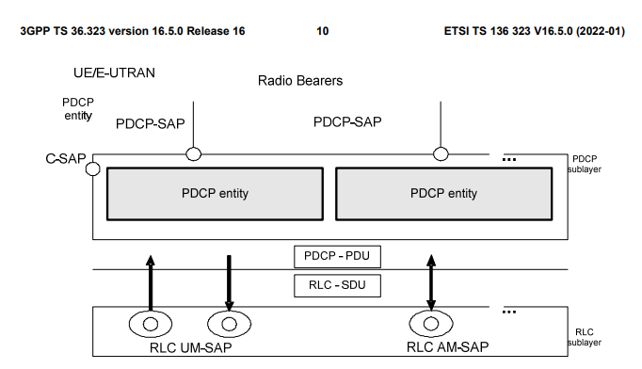

PDCP Entity:

In PDCP Entity we have Header compression and decompression, ciphering and deciphering, Integrity protection and verification,Routing/duplicatation and Adding header and Removing header.

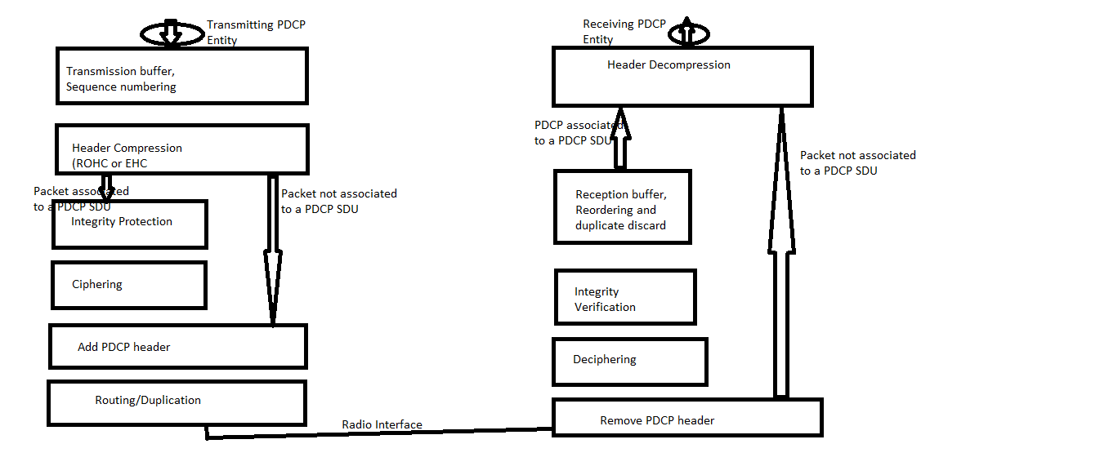

Sequence Numbering:

Why Sequence numbering means—

* Reordering
* Duplicate detection
* Integrity protection
* Ciphering

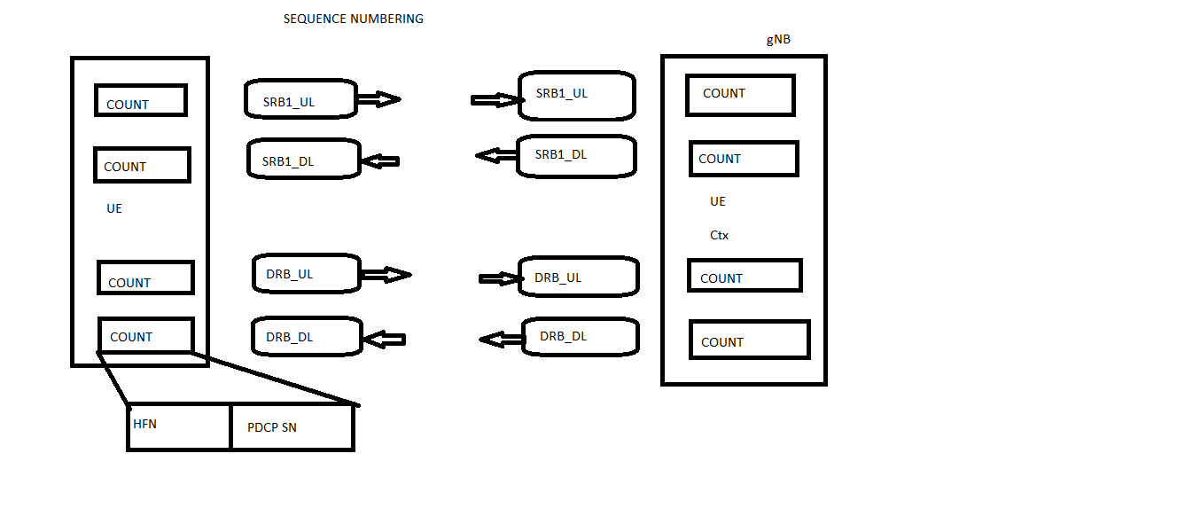

Header Compression:

Why header compression means -- Saving the bandwidth

How means—

* Removing redundant info
* Encoding important info
* HOP to HOP
* Unidirectional

In header compression supported profiles are

0x0000 - No compression

0x0001 - RTP/UDP/IP

0x0002 - UDP/IP

0x0003 - ESP/IP

0x0004 - IP

0x0006 - TCP/IP

0x0101 - RTP/UDP/IP

0x0102 - UDP/IP

0x0103 - ESP/IP

0x0104 - IP

Ciphering:

Why Ciphering means -- To protect the data over radio

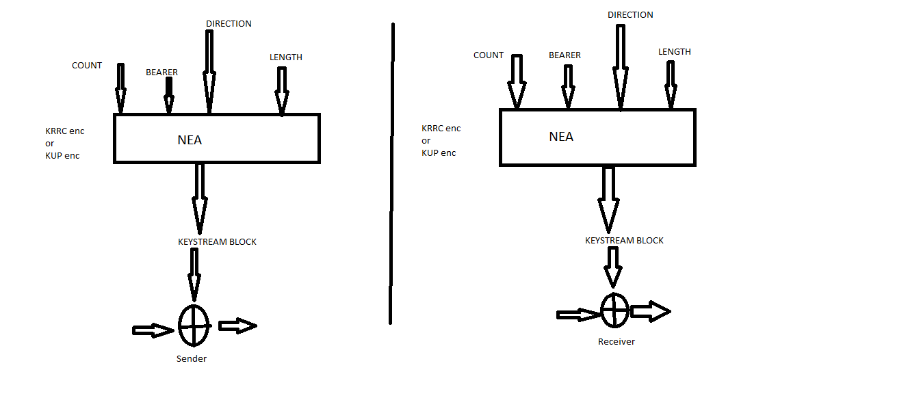

PDCP Data Duplication:

* Secondary RLC entity/logical channel is added to the DRB
* Increases reliability and reduces latency
* Configured by RRC
* If packet duplication is configured

1. Packet duplication can be activated or deactivated dynamically via MAC Control Elements(CE) for DRBs
2. Duplication is always active for SRB

* Duplicate discard based on RLC AM on transmitting side.